Specification Information
DECOTONE SURFACES ULTRA MAX ACRYLIC DECORATIVE SHEETS 2023-2024

- PRODUCT IDENTIFICATION:

DECOTONE SURFACES ULTRA MAX ACRYLIC SHEETS

2. General Description:

DECOTONE SURFACES ULTRA MAX HIGH GLOSS ACRYLIC PANELS 1.0MM THICKNESS

- Sheet sizes: 4’ x 8’

- Thickness Available: 1.0MM Thickness.

- Recommended Uses: Kitchen Cabinets, Closets, Interior Doors, Interior Furniture, Store Fixtures, and Trade Show Exhibits.

- Not recommended for: Areas exposed to high temperatures, or exterior use.

3. Adhesive
The use of PUR hot glue laminating lines is Recommended for the best resulting Gloss finish. When a PUR glue line is not available customers have used Contact adhesive as an alternative.
Because this is a high gloss OR Super Matte acrylic product, making sure that the spread of glue is very even and consistent is very important to avoid telegraphing.
We recommend the following Kleiberit ref. 709.3, Henkel ref. QR4663 or Jowat 609.20. Any other PUR hot glue should work fine. The glue must reach a temperature of up to 140ºC to be sufficiently liquid. The roller through which the glue is applied must be at a temperature of about 125ºC.

4. FABRICATION INSTRUCTION:

Machining, cutting and tooling are done using similar tools to processing high pressure laminate. When cutting the DECOTONE ULTRA MAX be sure to use a blade designed for use with acrylic or plastic materials. Feed rate for cutting may need to be faster compared to when cutting HPL in order to keep the acrylic material from melting slightly from heat of the blade.

5. HOW ARE decotone ultra max HIGH GLOSS SHEETS EDGES FINISHED AFTER LAMINATION.
Matching or very similar edges can be purchased from Dollken or Rehau companies.

6. IS IT POSSIBLE TO POSTFORM OUR decotone ultra max HIGH GLOSS?
It is possible to postform our product, and with the appropriate machinery, a minimum radius of 1.5mm can be achieved.
ABS/PMMA is a thermoplastic, this means that its shape can be modified if the right heat is applied to it. The most important aspect is to apply the heat at just the right angle. The applied heat should be higher than 110ºC.ss

7. ONCE THE dectone ultra max HIGH GLOSS material IS GLUED TO THE MDF, WHEN CAN WE CUT THE PANEL?
We recommend waiting at least 24 hours to cut the board until the glue has dried and stabilized.

8. IS IT POSSIBLE TO POLISH SMALL SCRATCHES? IF YES, WHICH PRODUCT SHOULD I USE?
1.- Small marks and scratches can be polished as the surface is acrylic. However, deep scratches cannot be erased, as the thickness of the methacrylate layer is only approx. 0.1mm.
2.- Any product for polishing will work correctly. For example, the products used to polish the bodywork of vehicles are suitable and can be found in any vehicle repair shop.

9. WHAT TYPE OF CLEANING PRODUCT CAN BE USED TO CLEAN THE SURFACE OF A decotone ultra max HIGH GLOSS DOOR?
We recommend cleaning the surface with a microfiber cloth and with liquid soap and water. Cleaners with antistatic properties are suitable for preventing static electricity.
We recommend a product called Vuplex which is a specific product for cleaning plastic. Vuplex is stocked at Decotone Surfaces.
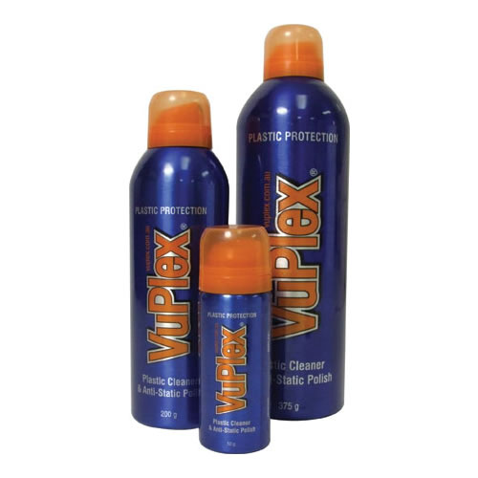

9. WHAT KIND OF CLEANING PRODUCT SHOULD BE USED TO CLEAN THE RESIDUE OF GLUE THAT MAY REMAIN ON A NORSAN HIGH GLOSS DOOR?
When removing the protective film, it is important to clean the adhesive residue from the surface of the sheet. Otherwise, it may appear that the surface has been scratched when handling it, when in fact it is traces of glue.
Our recommendation to clean the remains of glue is to use moistened microfiber cloths, cleaning the surface carefully. This simple procedure increases the scratch resistance of our foil, as well as the gloss of the surface.
In this case we also recommend the use of the Vuplex cleaner.

